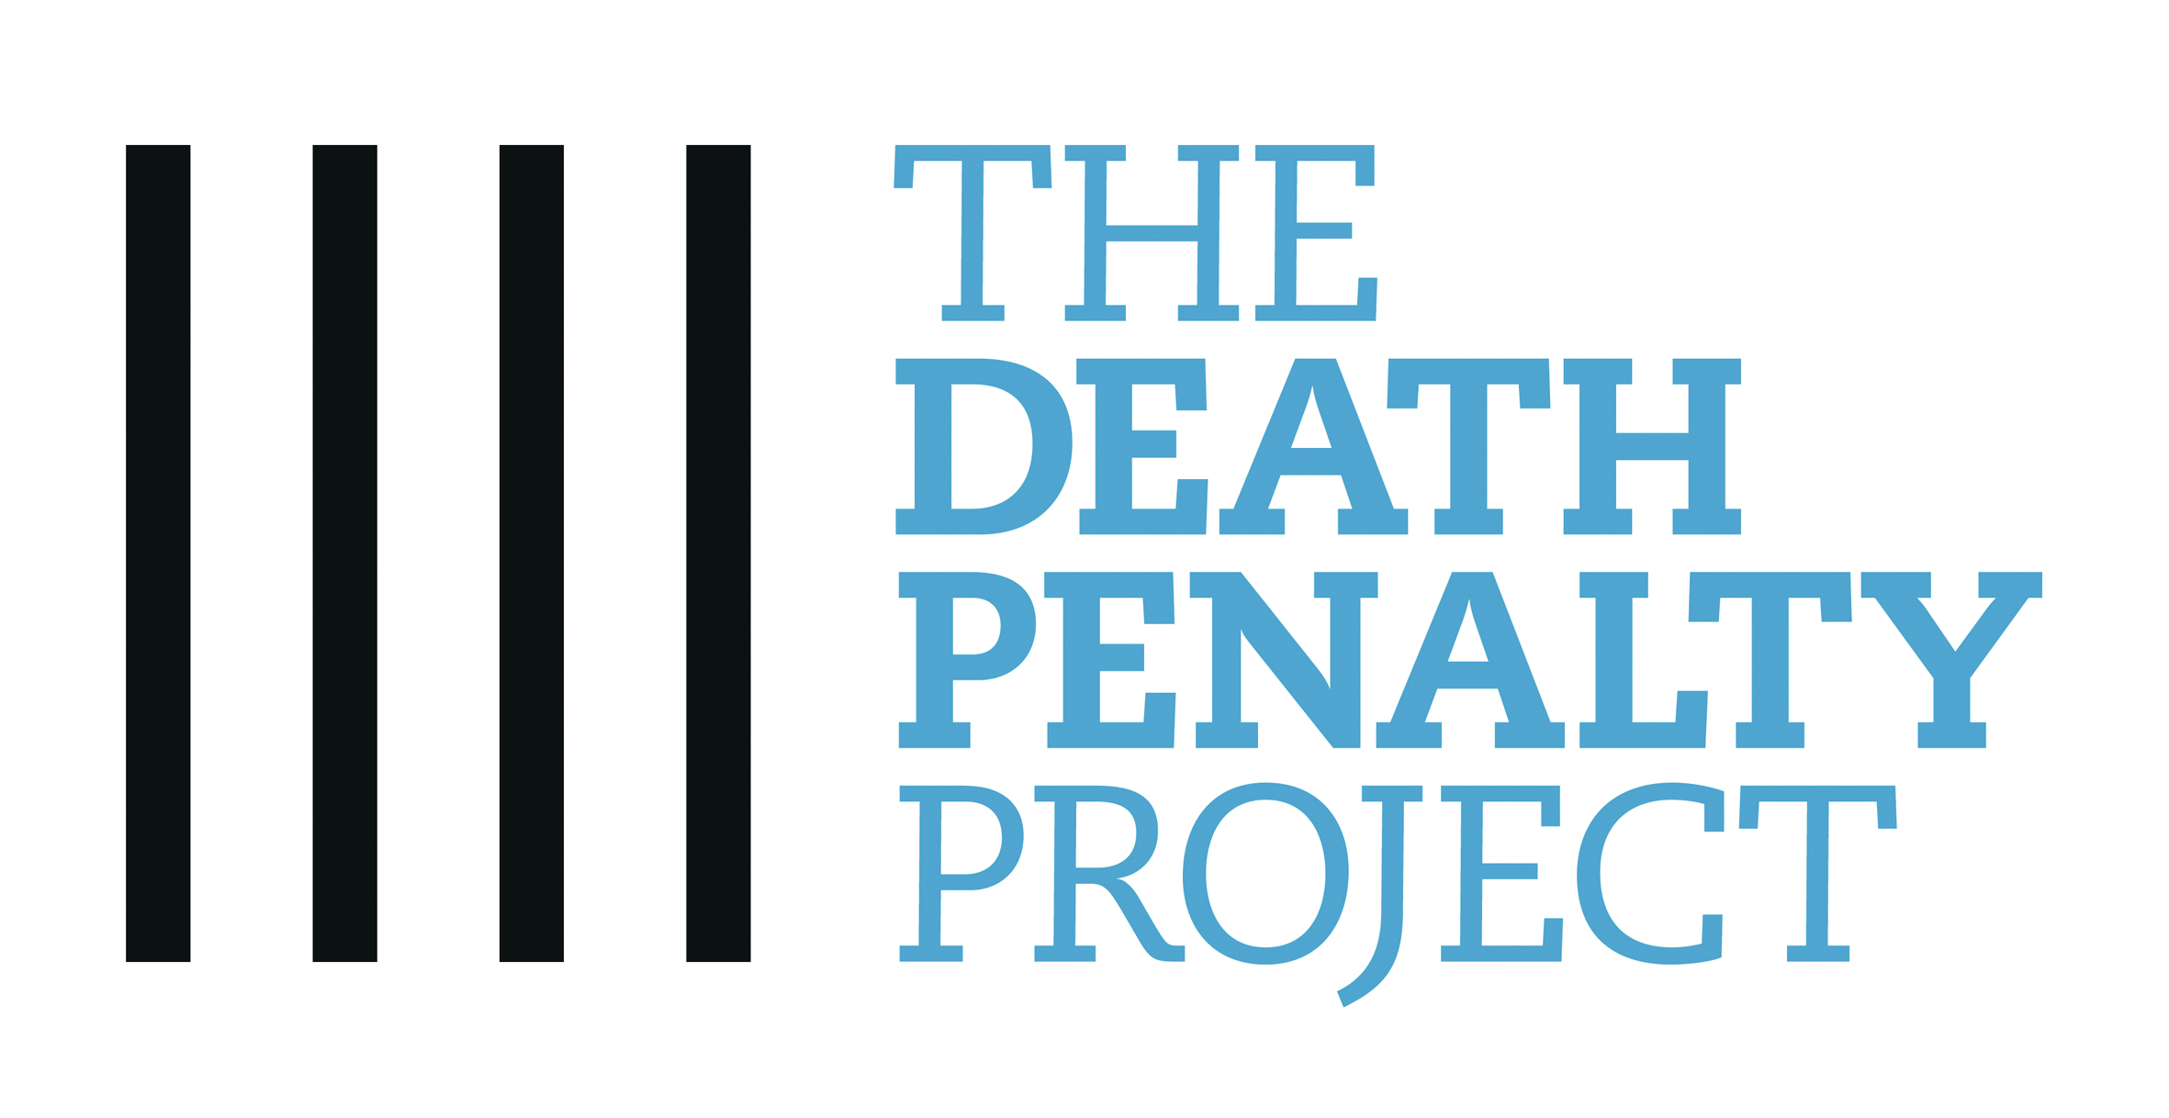
Press release

21 July 2015

HEADLINE: Murder conviction and death sentence quashed by Court for prisoner diagnosed with mental disorder

A manslaughter verdict was substituted today in place of a murder conviction for Stephen Robinson, for killing a security guard in Trinidad & Tobago in 2002. Robinson, who suffers from chronic schizophrenia, was convicted and sentenced to death in 2009, despite uncontroverted medical evidence which showed him to be affected by illness at the time.

The Privy Council, still Trinidad & Tobago’s highest court, said that Robinson unquestionably suffered from a chronic and incurable disease at the time of the killing and could not be said to be entirely responsible for his actions. Fresh evidence in the form of a forensic psychiatric report was provided to the court confirming the appellant’s medical condition.

Evidence of mental illness can mean the difference between life and death in Trinidad & Tobago where the death penalty is still mandatory for murder. However, raising the defence is often hampered by the lack of resources available for obtaining forensic psychiatric and psychological evaluations. In a series of case over the last decade, a large number of appeals have been allowed based on mental disorder

Next year, in appeals from Trinidad and Tobago, the Privy Council is to rule upon the constitutionality of imposing a death sentence on someone who suffers from mental disorder.

Note to Editors

About the Death Penalty Project

The Death Penalty Project is an independent international human rights organisation housed in the offices of Soho legal firm Simons Muirhead & Burton. For more than 20 years, The Death Penalty Project has worked to protect the human rights of those facing the death penalty.

Between 2011 and 2014, The Death Penalty Project carried out a series of training workshops for mental health and legal professionals in the Commonwealth Caribbean region. A Handbook of Forensic Psychiatric Practice in Capital Cases has also been published to assist medical practitioners and lawyers who are involved in capital cases. These activities highlight the human rights issues surrounding the imposition of the death penalty on persons with mental illness/impairment.

Paul Bowen QC from Brick Court Chambers and Stephen Broach from Monckton Chambers were instructed pro bono in this case, along with Amanda Clift-Matthews.

Dr Marc Lyall of Forensic Psychiatric Chambers was instructed pro bono to carry out an assessment of Mr Robinson and to provide expert evidence.

For further press information, please contact: Annette So on (+44) 203 206 2748

