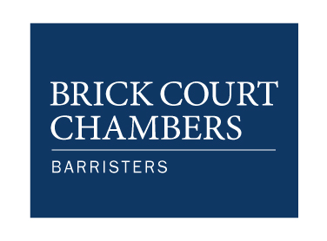

OPEN DAY

Thursday 20 March 2014

DRAFT PROGRAMME

10.30-10.45am Registration at the Parliament Chamber, The Honourable Society of The Inner Temple, London EC4Y 7HL (Nearest tube: Temple, District and Circle lines).

10.45-11.00am Coffee and welcome:

11.00 -11.20am The Commercial Bar:

11.20-11.40am EU and Competition Law:

11.40-12.00pm Public Law and Human Rights:

12.00-12.15pm Life as a pupil and junior tenant:

12.15- 12.30pm Pupillage and applications:

12.30- 12.45pm The Bar from the clerks’ perspective:

12.45 – 1.00pm Advocacy at the Bar:

1.00-1.45pm Sandwich lunch

1.45pm A visit to Brick Court Chambers and a tour of the RCJ.

