Speech at the reception to celebrate the 50th anniversary of David Vaughan CBE QC beginning practice in Brick Court Chambers

Jonathan Hirst collared me at a recent event to make sure that I wasn’t intending to speak for too long tonight, given that the guests would be on their feet. When David himself got wind of this, he looked thoughtful and then told me that I shouldn’t be too short either.

Someone said of Clement Attlee that he was a modest man with much to be modest about.
That is not something we could ever say about David.

David, of course, has an enormous amount to be thoroughly immodest about.

Let me give you two very recent tokens of his standing in the profession.

A few weeks ago I was privileged to give the first Annual David Vaughan QC Anti-Trust Lecture, initiated and sponsored by Clifford Chance. When some of David’s friends heard about it they were much relieved to find that he was still alive. It is, after all, not common to have an annual lecture given in your name when you are still in the land of the living.

But David is no ordinary person.

This October the new LCJ was swearing in the latest High Court Judge from Brick Court Chambers, Nick Green. At the start of his welcoming remarks to the assembled throng the LCJ described Nick as coming

“from the well-known stable of European law practitioners presided over by David Vaughan QC”.

The mere fact

-that one of the largest law firms on the planet has thought fit to honour David with an eponymous annual lecture – and to do so while he is not just still alive, but still practising at the Bar –

-and the fact that the LCJ can simply describe a new judge as a protégé of David Vaughan, without need for any further explanation-

is surely eloquent testimony to the uncommon quality of the man, and to his outstanding achievements over the 50 years of practice at Brick Court Chambers, which we are celebrating with David, Leslie, William and Kitty tonight.

Most of us are familiar with what those achievements are. Even so, it is surely right to remind ourselves of some of them.

One might first ask whether his background or early years provide any clues to the stellar career that was going to mark the mature man.

Of course, David comes from distinguished lineage. One of his ancestors fought against the Spanish Armada. How delightfully ironic that when another Spanish Armada came on the scene almost exactly 400 years later, the current representative of the family swapped sides.

Another ancestor was the British Resident in Hyderabad in the late 1700s. Some of you may have read William Dalrymple’s compelling account of the tragic love affair between James Kirkpatrick and Khair-un-Nissa the beautiful daughter of a Hyderabadi noble family. This marriage produced two children, William and Katherine or Kitty. Ring any bells?
Kitty Kirkpatrick was David’s direct ancestor.

As for the Vaughan side of the family, suffice to say that when house-hunting in Wales, it is difficult to find a village where David is not, or his family has not at some time been, Lord of the Manor.

I have not been able to glean much about his time at Eton and Cambridge. Someone who had been at school with David did once tell me that they remembered him as an earnest and very competitive young soccer player. I could well believe the bit about him being earnest and competitive, but I hadn’t really marked him down as an exponent of the beautiful game, or an early Beckham.

When he first came to the Bar he was a pupil of Lord Neill of Bladon and at some point shared digs – if that is the right word - with another young barrister who was also destined to do quite well – Brick Court’s very own former LCJ and President of the Supreme Court, Nicholas Phillips. It is generally understood that David was largely responsible for recruiting both Nicholas and the late and much lamented Bob Alexander, to our chambers.

This gift for talent-spotting was certainly to be deployed to good effect later, but it gave little clue to the success that has marked David’s own extraordinary career at the Bar.

For half a century “not out”, David has worked from Brick Court Chambers. Most of that time – well over 30 years - he has been in silk, developing an EU law practice that is simply unrivalled by any other member of the Bar. In that period he has appeared more than 100 times in the Court of Justice and General Court in Luxembourg, and he has pioneered EU law in the courts of this country, taking on (and often winning) the most unpromising and intractable cases - cases at which more timid and less creative lawyers would blanche. His fame is not, of course, limited to these shores or to the confines of the Luxembourg courts: “Maitre Vogon” has long been a celebrity in EU circles throughout Europe and beyond.

A few tit-bits from a dazzling array of cases may give the picture:

Many of the Spanish fishermen in David’s epic and ultimately successful battle with the UK government - the Factortame saga - were based in La Corunna. In that town David is regarded as a strong candidate for canonisation and deserving of a monument of his own, to rival the one to Sir John Moore.

In another outstanding achievement, he led B&Q’s legal team in a long war of attrition against the somewhat bizarre English & Welsh Sunday trading laws. David’s opening salvo in the European Court at one of many hearings over the course of a 5 or 6 year battle, was typical. It expressed what was at the heart of the legal argument, while at the same time making the member of the Court chuckle: “My lords, it is well-known that shops sell more when they are open than when they are closed.”

In Cyprus he is a hero in the light of his victories in the Anastasiou litigation, and much more recently we can point to David’s efforts on behalf of the People's Mojahedin of Iran. Nearer to home, the truly astonishing successes for ICI over a quarter of a century or more, are now the stuff of legend.

Of course there are countless other cases that would merit a mention, including those where David has taken what proved to be a pioneering stand, or has snatched victory in the most unpromising of circumstances. The list of battle honours is lengthy. No wonder he is described as “a legend”, “a great motivator and team player”, “a great fighter”, “innovative”, “silk of choice”, and “doyen of competition law”, to mention just a few of the accolades in legal directories over the years.

Part of his secret may be that he is not given to pusillanimous advice. When asked by clients what are the percentage chances of winning, his answer tends to be one of only two alternatives: “bound to win” or “bound to lose”. Clients appreciate this approach, which affords them certainty of the result. However, juniors, sent off by David after the conference to prepare a written pleading or advice substantiating the “bound to win” version, can occasionally feel their enthusiasm diminished.

Another initiation test for any legal team working with David is to be required to interpret his copious but essentially illegible handwritten annotations on a draft document. After many years of practice I felt reasonably confident that I could get at least the gist of what he had written. Somerville & Ross, the authors of “The Adventures of an Irish RM”, described the handwriting of the formidable Mrs Knox in terms which are precisely applicable to David:

“No individual word was decipherable, but, with a bold reader, groups could be made to conform to a scheme based on probabilities.”

But it would be wrong to think that he is just a very successful barrister. He has in addition excelled in a bewildering number of other areas. I am not just referring to some of the conventional marks of high professional standing: he has of course been appointed a deputy High Court judge, and a judge of the prestigious Courts of Appeal of Jersey and Guernsey; he is naturally a Bencher of his Inn, and has served on the Bar Council in various capacities, and was the first Leader of the European Circuit. But there is much, much more.

For example, in about 1977 he started a law partnership in Brussels with two other English barristers. This entity, entirely revolutionary at the time, was the precursor of the current Brick Court Chambers Brussels.

At about the same time he was a founding member of the Bar European Group, a Bar association which is still thriving today under the Presidency of Lord Justice John Laws and the Honorary Vice-Presidency of – who else - one David Vaughan QC. In the 25 or so years since I have been a member of that Group I cannot remember a time when David has not attended the annual conference – often with Leslie and the family.

At what was probably the most frenetic period of a generally fast-paced, high level practice, David somehow managed to conceive and create, as well as writing part of, a substantial two-volume addition to Halsbury’s Laws of England. This, for the first time, provided comprehensive and authoritative coverage of the width and complexity of European law.

He combined all these activities with his duties as Visiting Professor of European Law at Durham University, and with the delivery of countless other papers, lectures and contributions to EU law at innumerable conferences and seminars around the world.

As if that isn’t enough, he has been the driving force behind, and Managing Trustee of, the Lord Slynn Foundation, set up by his great friend and mentor Gordon Slynn, with the aim of training judges of the new Member States in the principles of EU law.

I have already mentioned David’s gift for talent spotting. That is only half the story because as well as spotting the talent, he has demonstrated time and time again over the years his knack of acquiring that talent for chambers, and then putting it to good use. For quite a while he was virtually alone in chambers in recognising the importance and potential of European law for practice at the Bar. This was still more or less the position when I joined him in 1981. He and I sat in a garret in 11 Essex Street, representing the totality of “the Euros” in Chambers. The reason this changed, with Brick Court now the foremost EU law set in the country, boasting umpteen eminent silks and juniors specialising in this field, is down to this skill which David has in identifying the right sort of bright people, and ensuring that they come to these Chambers. The beneficial impact of this on the reputation and success of Brick Court as a whole is without doubt one of David’s greatest and lasting achievements. It is an achievement for which Chambers, and many of us who are here tonight, have reason to be grateful.

Nor was this talent spotting ability restricted to his professional life. The time came when he spotted Leslie. It was obvious to all who knew David that from then onwards his life was transformed. The great professional success he has enjoyed must surely be due in no small part to the happiness and support he obtains from Leslie. This is despite the fact that on their wedding day David’s bull terrier, China, left alone with Leslie’s beloved chihuahua, ate it. It could all have ended there for David and Leslie, but thankfully it didn’t, and William and Kitty are here to prove it.

Leslie obviously relishes a challenge. Despite those early foot-balling skills, David has not always displayed the slim, youthful figure you see today. He has generally been fairly keen on nourishing the inner man, and it must have been an heroic struggle for Leslie trying to keep the inner man within external bounds. Once, when some of us staying at a hotel for a law conference, Myriam my wife went for an early morning swim, only to find Leslie making David do ballet exercises in the pool. “No, David, you can have breakfast when you’ve done 6 more plies”.

It is hardly surprising that David has been honoured by the Queen with a CBE, and it is wholly appropriate that Chambers should wish to mark this very significant anniversary of David’s starting out at Brick Court.

Before I finish:

- A telegram has been received from David Anderson QC, another very distinguished protege of that David Vaughan stable of which the LCJ spoke. He is currently in Israel, and writes:

"Very sorry to miss the party. David rarely failed to win and never failed to entertain, whether he was knocking over Acts of Parliament or eating the magistrates' steaks during the short adjournment. Heartfelt congratulations to my father in the law. Young David."

- Finally, we have a small gift for David. It is a little overdue. After the House of Lords confirmed in one of the Factortame decisions that Acts of Parliament were no longer sacrosanct and could be disapplied if they did not conform to overriding rules of EU law, questions were asked in the House, and a learned academic wrote an article arguing that the UK’s grundnorm or basic law had now been shifted as a result of the case. It was decided by the Factortame legal team that, to commemorate such a significant event, there should be a tee-shirt, saying “We shifted the grundnorm”. Myriam volunteered to do the artwork. It is now ready. The passage of time has rendered the idea of the tee-shirt less appealing, and so Myriam has produced a watercolour painting of an allegorical nature, which we hope will remind you of the many happy hours spent shifting the grundnorm.

The Honourable Mr Justice Barling
26th November 2013

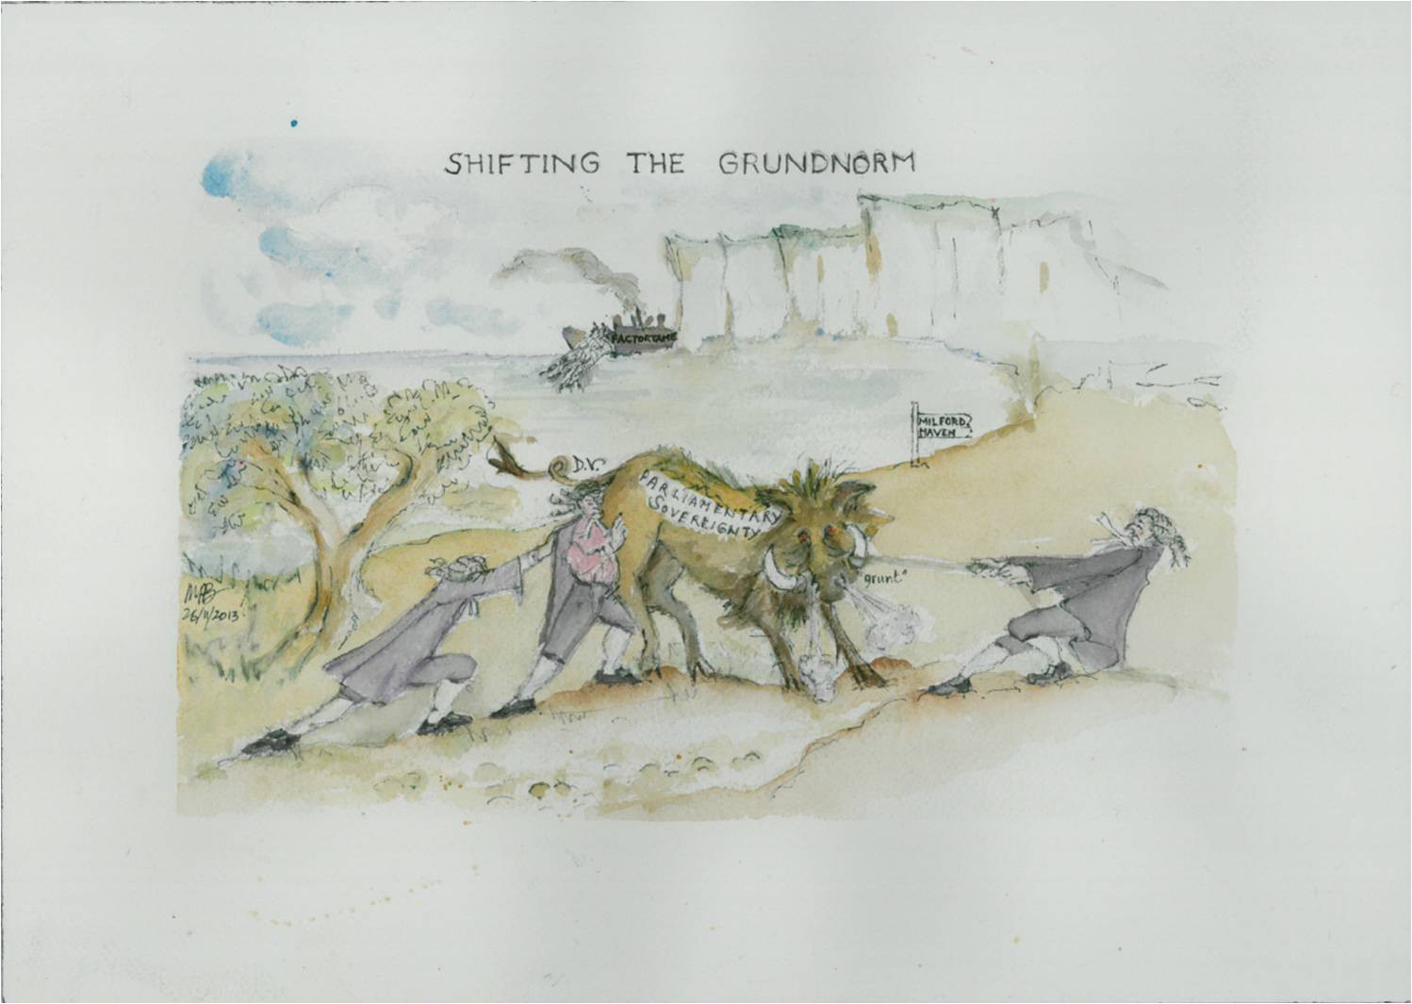

Picture: Myriam Barling

