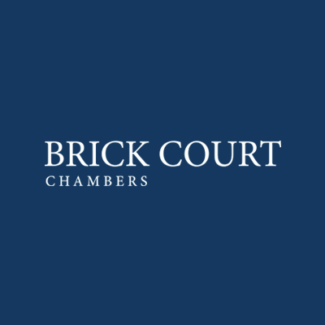

OPEN DAY

Wednesday 24 September 2025

DRAFT PROGRAMME

10.00am -10.25am Registration and coffee at the Lecture Theatre (Third Floor),
The Honourable Society of the Inner Temple, London EC4Y 7HL
(Nearest tube: Temple: District and Circle lines)

10.30am -10.40am Welcome:

10.40am – 11.00am Pupillage and Applications:
11.00am – 11.40am Pathways to the Bar:
Life as a pupil and junior tenant:
Work/Life balance at the Bar:

11.40am – 11.50am Short break

11.50am - 12.05pm Commercial Law:

12.05pm - 12.20pm Competition Law:

12.20pm - 12.35pm Public Law and Human Rights:

12.35pm -12.50pm International/EU Law:

12.50pm – 1.00pm Advocacy at the Bar - oral and written:

1.00pm – 2.15pm Sandwich lunch with members of Brick Court Chambers.

